

SUMMER INTERNSHIP – A PROJECT REPORT
on
MALL CUSTOMER ANALYSIS

Submitted by
SUBHAA SHRI.P (24127062)

BACHELOR OF COMPUTER SCIENCE
WITH DATA ANALYTICS

MAY- 2025

BONAFIDE CERTIFICATE

Certified that this project report “ MALL CUSTOMER ANALYSIS ” is the bonafide work of “SUBHAA SHRI P (24127062)” who carried out the project work under my supervision.

SIGNATURE OF GUIDE SIGNATURE OF HOD

Dr.Ginne M Jame Dr.B.Vidhya MCA.M.Phil.Ph.D
HEAD OF THE DEPARTMENT
COMPUTER SCIENCE WITH DATA ANALYTICS
SRI RAMAKRISHNA COLLEGE OF ARTS & SCIENCE

ASSITANT PROFESSOR
COMPUTER SCIENCE WITH DATA ANALYTICS
SRI RAMAKRISHNA COLLEGE OF ARTS & SCIENCE



TABLE OF CONTENT

CHAPTER NO | TITLE | PAGE N0
 | INTRODUCTION  1.1. Background  1.2 Problem Statement  - Purpose of the Study | 5-6
2. | OVERVIEW OF THE PROBLEM  2.1Customer Behavior in Retail Environments  2.2 The Role of Data Analytics in Retail  2.3 Challenges  2.4 Software, Tools and Libraries Requirements  2.5 Hardware/System Requirements | 7-8
3. | PREPARATION  3.1 Data Collection Approach  3.2 Data Description and Structure  3.3 Data Cleaning and Preprocessing  3.4 Purpose of Data Preparation | 9
4. | METHODOLOGY  4.1 Exploratory Data Analysis (EDA)  4.2 Univariate Analysis  4.3 Bivariate Analysis  4.4 Data Transformation | 10-11
5. | RESULTS, FINDING INSIGHTS AND DISCUSSION | 12-20
6. | SUMMARY AND CONCLUSION | 21
7. | REFERENCES | 22
8. | APPENDIX | 23-25

CHAPTER I
INTRODUCTION

1.1 BACKGROUND
The retail industry, particularly in the context of mall shopping, has seen significant evolution with the advent of technology and digital transformation. Malls serve as a dynamic environment where diverse consumer behaviors, preferences, and purchasing patterns converge. Understanding these behaviors is crucial for mall management, retailers, and marketers to create personalized experiences, improve customer satisfaction, and drive sales. In recent years, the emphasis has shifted towards data-driven decision-making, where insights derived from customer data play a key role in shaping strategies for store placement, marketing campaigns, inventory management, and more.
Given the growing importance of customer experience and retention, a deeper understanding of mall customer demographics, foot traffic, purchase behavior, and preferences can help in creating more effective business strategies. By leveraging tools such as data analytics and machine learning, mall operators and retailers can not only gain a comprehensive view of customer habits but also predict future trends and optimize operations accordingly. This project aims to analyze the behavior of mall customers by gathering data from various sources, such as sales records, loyalty programs, and foot traffic sensors, to provide actionable insights for improving customer engagement and business performance within the mall

1.2 PROBLEM STATEMENT
Despite the abundance of customer data in mall environments, many retail businesses and mall operators struggle to fully leverage this information to enhance customer engagement and optimize operations. The lack of integrated data analysis tools often results in missed opportunities for improving customer experience, personalizing marketing efforts, and boosting sales performance. Traditional approaches to understanding customer behavior are often fragmented, relying on basic transactional data without considering factors like foot traffic patterns, dwell times, and individual customer preferences.
This project aims to address these challenges by developing a data-driven solution that analyzes mall customer behavior through the integration of multiple data sources. The problem lies in the effective collection, analysis, and interpretation of this data to deliver actionable insights that can influence decisions related to store placements, marketing campaigns, customer segmentation, and product offerings. Without a comprehensive system to synthesize and visualize customer data, mall operators and retailers cannot fully capitalize on the potential to enhance customer experiences and drive business growth. This project seeks to create a solution that provides mall managers and retailers with a clear understanding of their customers, thereby improving strategic decision-making and increasing customer satisfaction.

1.3 PURPOSE OF THE STUDY

The primary purpose of this study is to harness data analytics to gain a deeper understanding of customer behaviors within the mall environment. By integrating data from various sources—such as sales transactions, loyalty program analytics, foot traffic monitoring, and social media interactions—the study aims to create a holistic view of the customer journey. This will enable mall operators and retailers to uncover valuable insights, including customer preferences, shopping patterns, and response to marketing strategies.
Specifically, this study seeks to achieve the following objectives:
- Identify Key Customer Segments: Determine distinct customer groups based on demographics, purchasing habits, and behaviors to facilitate targeted marketing strategies.
- Optimize Store Layout and Product Placement: Use insights from foot traffic data to recommend optimal store layouts and product placements that enhance visibility and drive sales.
- Enhance Marketing Effectiveness: Tailor marketing efforts by analyzing customer responses to different promotional strategies and campaigns, improving the relevance and impact of communication.
- Improve Customer Experience: Leverage data to personalize the shopping experience, making it more enjoyable and increasing customer loyalty and retention.
- The goal is to empower mall operators and retailers with actionable data that can inform strategic decisions, streamline operations, and ultimately enhance the overall customer experience, thereby driving profitability and sustainable growth within the competitive retail landscape.

CHAPTER II
OVERVIEW OF THE PROBLEM
2.1 CUSTOMER BEHAVIOR IN RETAIL ENVIRONMENTS
Understanding customer behavior in a retail setting is critical for shaping strategies that enhance customer satisfaction and drive sales. Previous studies have shown that customer behavior in malls is influenced by a combination of environmental, social, and psychological factors. Environmental factors such as store layout, signage, and lighting significantly impact a customer’s decision-making process. Social influences, including peer behavior and online reviews, also play a key role in shaping purchasing decisions. Psychological factors such as customer attitudes and perceptions towards the mall affect their overall shopping experience and retention. These studies emphasize the importance of understanding the customer as a complex entity whose behavior can be influenced by a variety of factors.
2.2 THE ROLE OF DATA ANALYTICES IN RETAIL
With the advancement of technology, retail businesses have increasingly turned to data analytics to gain deeper insights into customer behavior. Data collected from various touchpoints, such as point-of-sale systems, loyalty programs, and mobile apps, can be analyzed to uncover patterns and trends in customer behavior . Data analytics allows retailers to segment customers more effectively, predict future purchasing behaviors, and tailor marketing efforts. Furthermore, with the integration of machine learning algorithms, data can be used to predict customer preferences and demand trends, thereby optimizing inventory management and sales strategies .
The use of data analytics also extends to optimizing store layouts and product placement. Studies have demonstrated that analyzing foot traffic patterns and dwell times within different areas of the mall can guide decisions on store positioning, promotional displays, and aisle layouts . By understanding where customers spend most of their time, mall operators can strategically place high-margin or in-demand products to increase visibility and sales.
2.3 CHALLENGE
While data analytics offers immense potential, several challenges remain in fully harnessing its power within mall environments. One key challenge is the integration of diverse data sources, such as foot traffic, sales data, and online customer interactions, into a unified system for analysis. Many malls and retailers still operate in silos, making it difficult to generate actionable insights across all touchpoints (Fitzgerald et al., 2019). Additionally, privacy concerns and the ethical use of customer data remain significant barriers, particularly as data collection methods become more invasive (Martin & Shriver, 2018). Ensuring customer data privacy while still gaining valuable insights is a delicate balance that mall operators and retailers must address.
Moreover, the skills required to analyze and interpret large datasets can be a barrier for smaller retailers or mall operators without dedicated data science teams. There is also the challenge of ensuring that insights from data analysis translate into effective business strategies and are implemented efficiently across all departments within a mall or retail chain.
2.4 SOFTWARE,TOOLS AND LIBRARIES
- Operating System: Windows 7, 10, 11,Linux
- Programming Language: Python
- IDE/Workbench: Pycharm, visual Studio code
- Libraries: Pandas,numpy, matplotlib, seaborn
2.5 HARDWARE/SYSTEM REQUIREMENTS
- Processor: Core i5 or greater
- Hard Disk: 512GB or more
- RAM: 16GB or more

CHAPTER III
PREPARATION
3.1 DATA COLLECTION APPROACH
The dataset utilized in this study is the Mall Customer Segmentation Data, which is accessible publicly through repositories such as Kaggle. Essentially, the dataset comprises the profile data for 200 customers who visited a shopping mall. The data has been saved in a CSV file and read into a Python environment using the pandas software.The collection method did not rely on real-time scraping or API extraction; instead, a static and reliable dataset was chosen to make the analysis simpler and to concentrate on the clustering method.
3.2 DATA DESCRIPTION AND STRUCTURE
In the dataset there are five main features: CustomerID, Gender, Age, Annual Income (k$), and Spending Score (1-100). Every row represents the data of a single customer. CustomerID was utilized as an identifier, thus it was omitted from the analysis.The attribute of the data named Gender is of a categorical type while the Age, Annual Income, and Spending Score are numerical types. The Spending Score feature is mainly interesting as it is a reflection of the customer's involvement and a representation of her/his spending on a scale of 1 to 100. These features allow a simple but strong basis to do segmentation by using clustering.
3.3 DATA CLEANING AND PREPOCESSING
As the dataset was well-organized and clean, only minimal preprocessing was performed. A quick examination with .info() and .describe() corroborated that there were no missing values or null entries. Also, categorical variables such as Gender were taken into consideration for visualization but were not used in the clustering model since K-Means requires numeric data. For the clustering task, only the relevant numerical features—Annual Income and Spending Score—were selected since these parameters show clear patterns that are suitable for segmentation. Although feature scaling was discussed, due to the similar range of values, it was not necessary in this case.
3.4 PURPOSE OF DATA PREPARATION
The purpose of the data preparation stage was to guarantee that the data was fit for effective analysis and modeling. Efficient preparation assures that the clustering algorithm gets clean and relevant inputs, which in turn, directly influences the quality of the results. Through filtering the dataset and electing only the useful variables, we have less noise and are no longer prone to misleading groupings of the data. The data prep step has a crucial function in matching the input features with the K-Means algorithm's needs and establishing the basic framework for precise segmentation.

CHAPTER IV
METHODOLOGY
4.1 EXPLORATORY DATA ANALYSIS (EDA)
The first and foremost step in the analysis was the implementation of Exploratory Data Analysis (EDA). This process was crucial for understanding the basic structure and properties of the dataset. EDA is a technique used to summarize the main characteristics of a dataset, often visualizing them to discover patterns, detect anomalies, test hypotheses, and check assumptions.In this project, EDA allowed for a visual and statistical overview of customer attributes such as Age, Gender, Annual Income (k$), and Spending Score (1–100). Through this phase, it was possible to detect outliers, missing values, skewed distributions, and trends in the dataset. For instance, plotting the distribution of Age revealed a higher concentration of customers in the 20–40 year range, implying that malls cater mostly to young and middle-aged adults.Similarly, histograms and count plots were used to assess the balance between male and female customers. The Annual Income and Spending Score features displayed a wide variation, suggesting the potential existence of distinct customer types or groups. These initial findings played a vital role in selecting suitable features for the clustering process and verifying the dataset’s compatibility with unsupervised machine learning techniques like K-Means clustering.
4.2 UNIVARIATE ANALYSIS
One variable is the focus of univariate analysis. The aim is to know their features and how they are spread. In the current project, the univariate analysis was carried out on four main variables, i.e., Gender, Age, Annual Income (k$), and Spending Score (1–100). The gender distribution revealed that the customer base consisted of nearly equal numbers of males and females. A chart illustrated the frequency along with some descriptive statistics, which showed the majority of the customers belonging to the 20 to 40 years old age group. The annual income was very diverse with the lowest being $15,000 and the highest $137,000, while the spending score — a number given by the mall that represents the level of a customer's involvement — was distributed across the entire 1–100 range. These analyses brought to the lime light the dataset’s diversities and formed the basis on which the decision to segment the data henceforth was made.
4.3 BIVARIATE ANALYSIS
Bivariate analysis was done to observe the connection between two variables. The most important focus was on studying the correlation between Annual Income and Spending Score, since these were the two attributes considered for clustering. A scatter plot of these variables showed that customers with high income did not necessarily have a high spending score, and those with a high spending score were not always high-income earners. This suggests that income alone was not a significant characteristic that could help pick the spending behavior. Additionally, box plots based on gender were made to explore if those spending habits were different in males and females. Such bivariate relationships thus not only helped reveal the hidden nature of customer behavior, but they also laid down the application of the K-Means algorithm.
4.4 DATA TRANSFORMATION
Data transformation was carried out before clustering so as to get the dataset in a suitable form for modeling. Since K-Means utilizes numerical data only, it was necessary to leave out categorical variables such as Gender from the clustering process. The two variables we take for clustering are Annual Income (k$) and Spending Score (1–100) which are numeric in nature and have nearly compatible scales, thus feature scaling is not compulsory in this case. A subset of the original dataset containing only the selected features was created. This transformed data was then passed to the clustering algorithm. Suitable data transformation technique thus proved to be a critical step in the entire process as it ensured that the input fed into the machine learning model was accurate, relevant, and allowed for precise segmentation.

CHAPTER V
RESULTS, FINDING INSIGHTS AND DISCUSSION
5 ABOUT THE DATASET
The dataset applied in this research is known as the Mall Customers Dataset consisting 200 of customers that visited a mall. Each record in the dataset represents a customer and includes the following fields: CustomerID, Gender, Age, Annual Income (k$), and Spending Score (1–100). Spending Score is the number given by the mall to customers that they think represents their spending behavior and loyalty on a scale from 1 to 100. For clustering purposes, the two most relevant features — Annual Income and Spending Score — were chosen. These features allowed us to detect purchasing patterns and classify customers who have similar financial behavior. The dataset is clean, well-structured, and does not contain missing values, making it perfect for use in machine learning.
  - IMPORTING THE LIBRARIES FOR ANALYZING
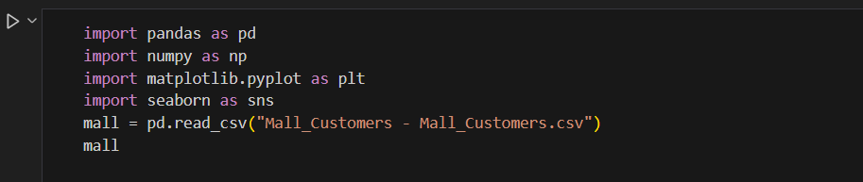
5.2 LOADING AND VIEWING THE DATASET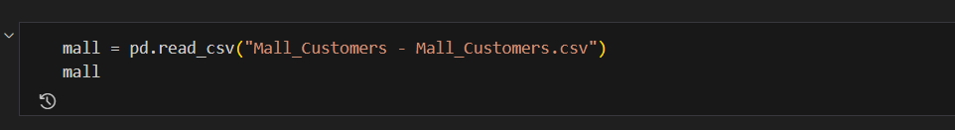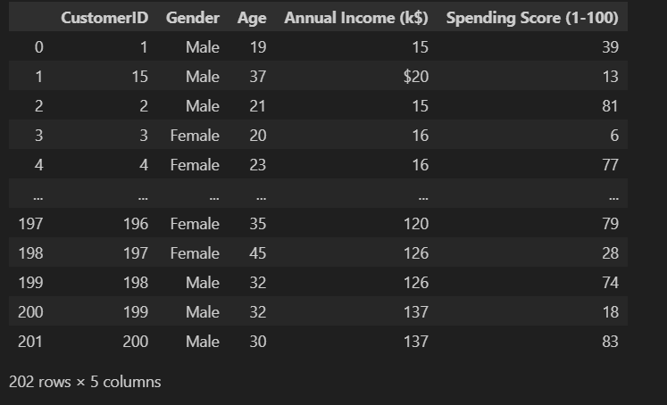
5.3 KNOWING ABOUT THE DATASET
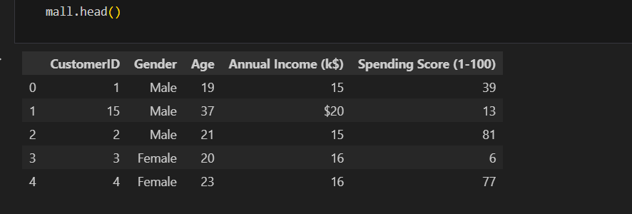
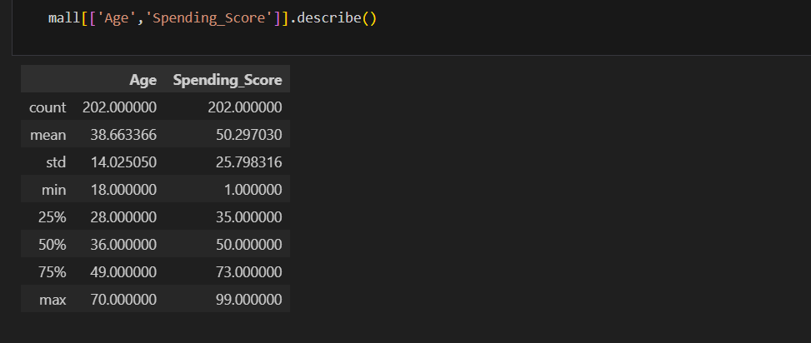
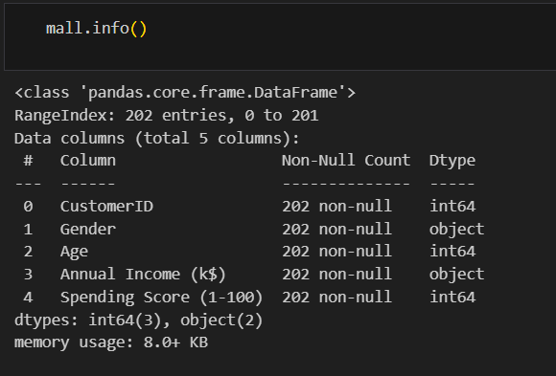
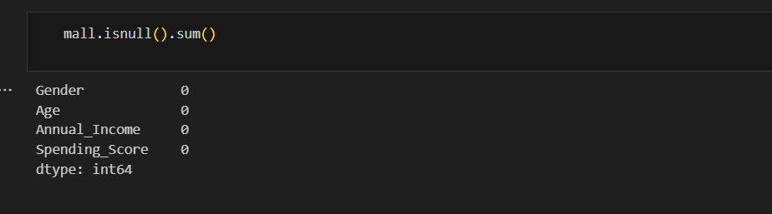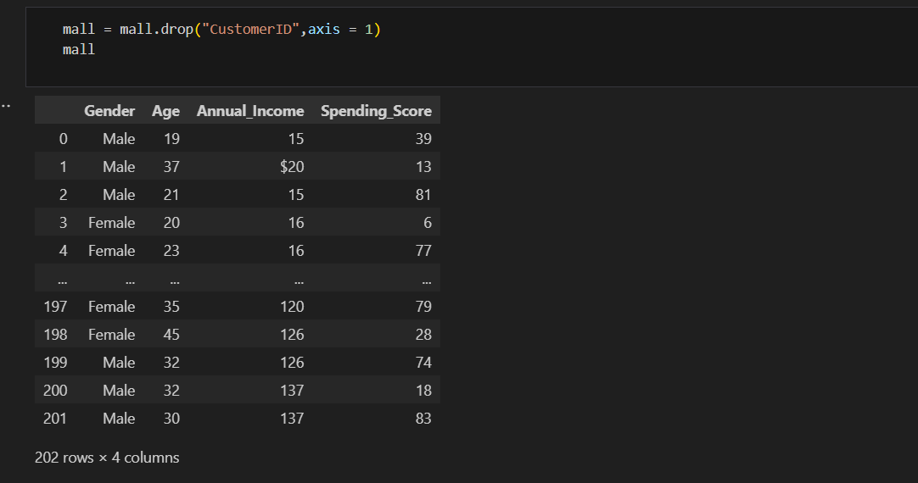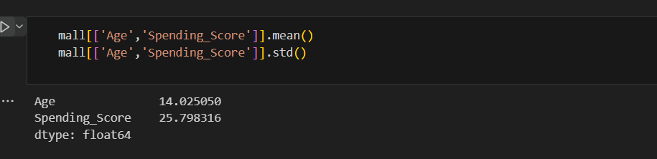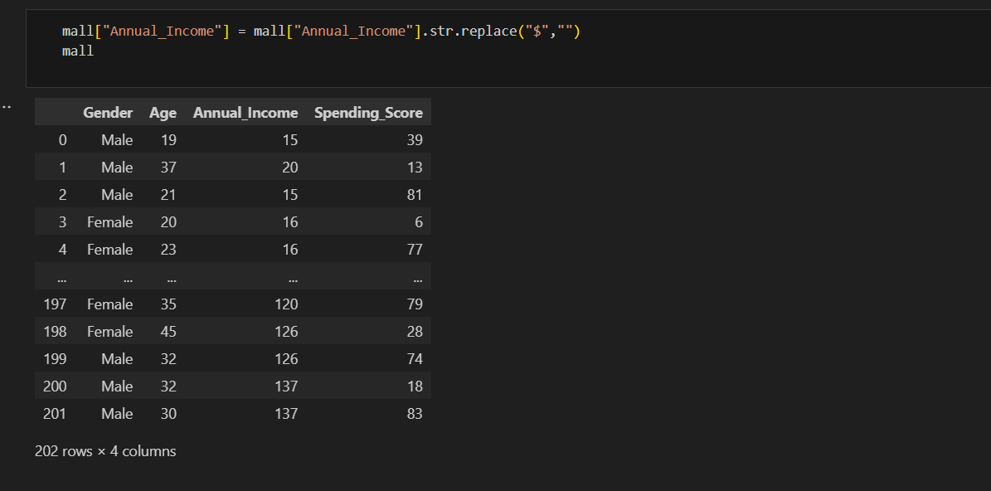5.4COUNT COMPARISON OF AVERAGE SPENDING SCORE BY GENDER 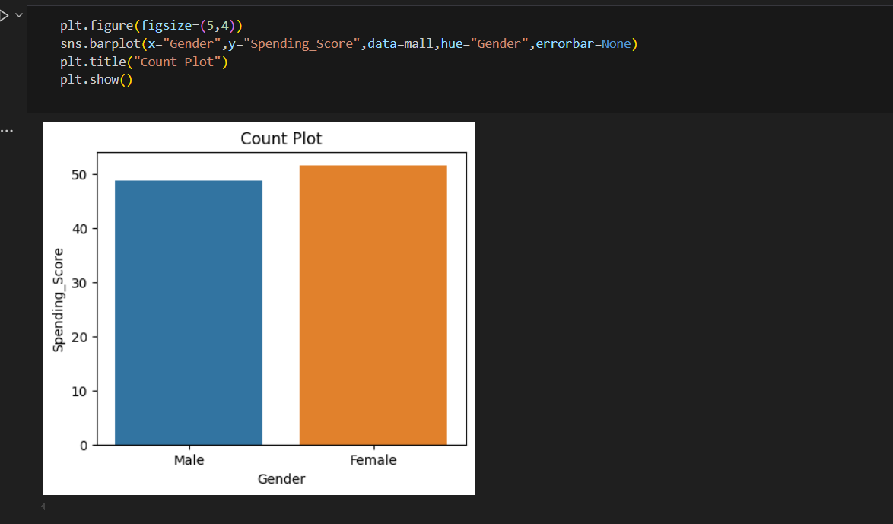
Figure 1
This bar plot illustrates the average spending score for male and female customers. It shows that female customers have a slightly higher average spending score compared to males, indicating stronger purchasing behavior.
5.5 COUNT DISTRIBUTION OF CUSTOMER BASED ON AGE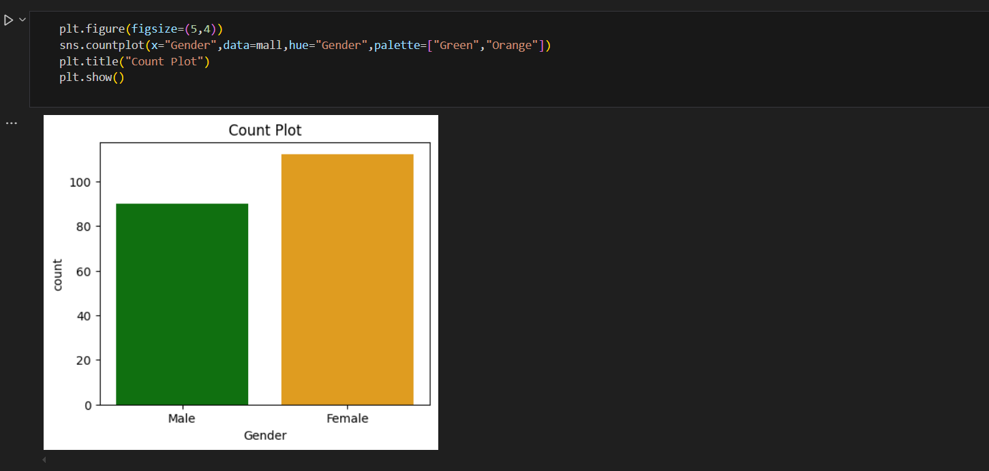
Figure 2
This count plot displays the number of customers categorized by gender. The chart suggests a higher number of female customers than male customers in the dataset, providing insight into the gender-based distribution.
5.6 COUNT DISTRIBUTION OF CUSTOMER BASED ON SPENDING SCORE
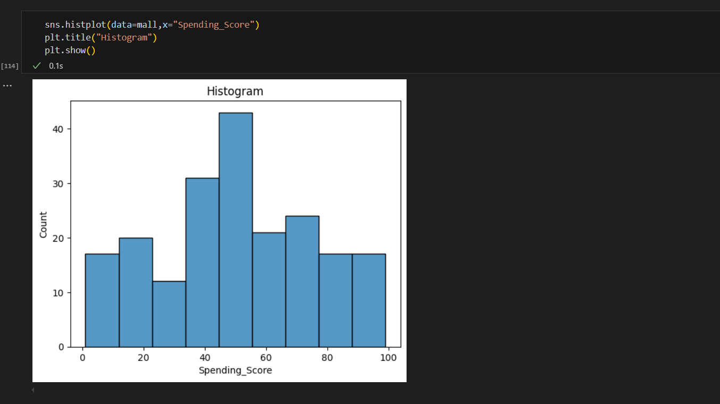
Figure 3
This histogram displays how customers are distributed based on their spending score. Most customers fall in the mid-range (40–60), indicating moderate spending behavior across the majority of the dataset.
5.7 COUNT DISTRIBUTION OF CUSTOMER BASED ON ANNUAL INCOME
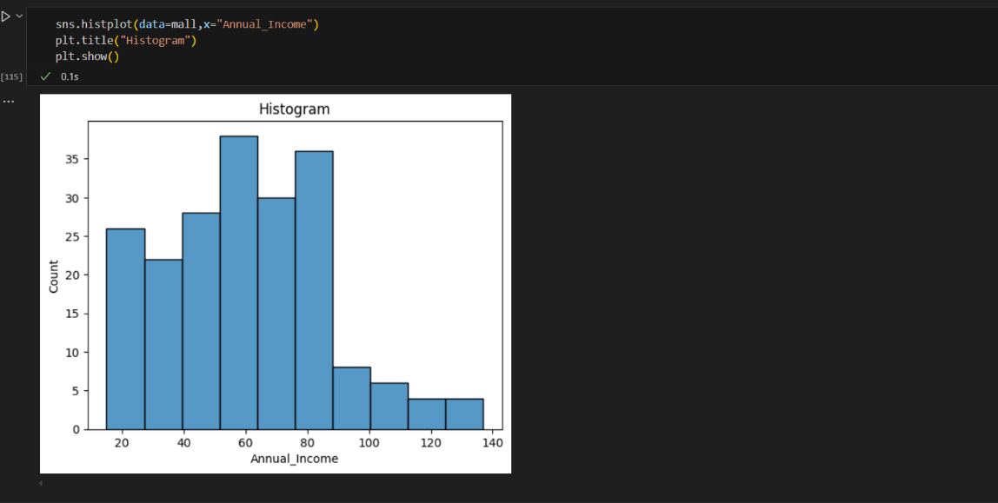
Figure 4
The histogram shows the distribution of customers by annual income. A large number of customers earn between 40k–80k annually, while fewer fall into higher income brackets above 100k.
5.8 TO ANALYSE THE AGE DISTRIBUTION AMONG GENDER USING BOX PLOT
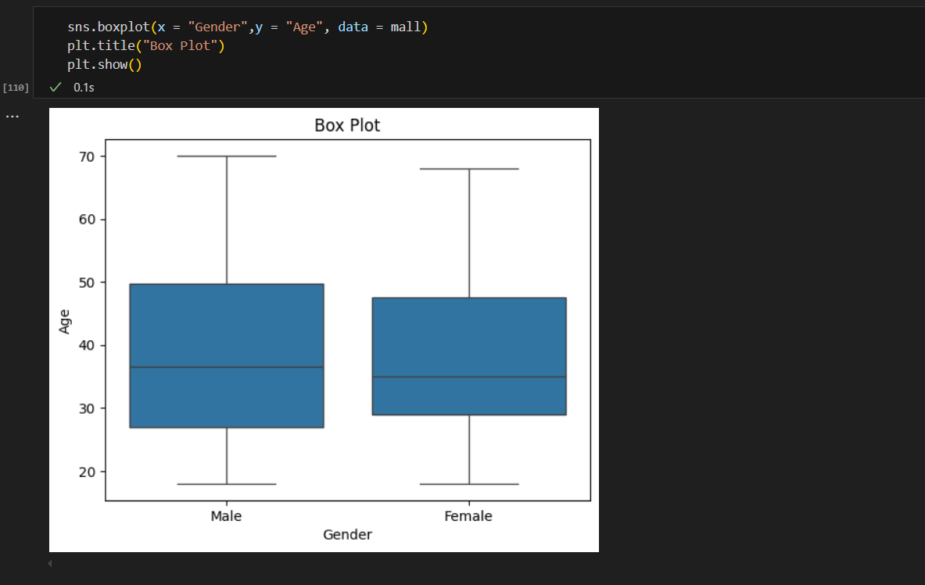
Figure 5
The box plot shows the distribution of age across male and female customers. Both genders have a similar median age, but the spread and outliers slightly differ, offering insights into age variability.
5.9 TO ANALYSE THE DISTRIBUTION OF SPENDING SCORE ACROSS GENDERS USING BOX PLOT
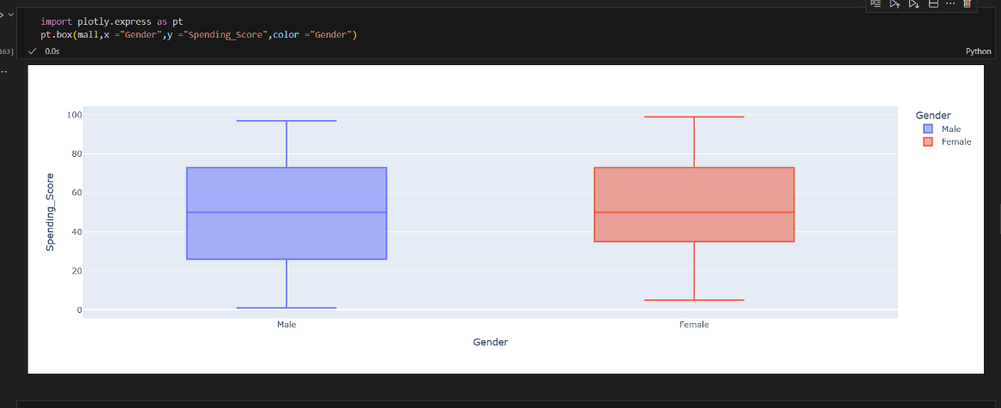
Figure 6
This visualization highlights how spending scores vary between males and females. The distribution shows females tend to have slightly higher spending tendencies on average.
5.10 TO ANALYSE THE DISTRIBUTION OF ANNUAL INCOME ACROSS GENDERS USING BOX PLOT
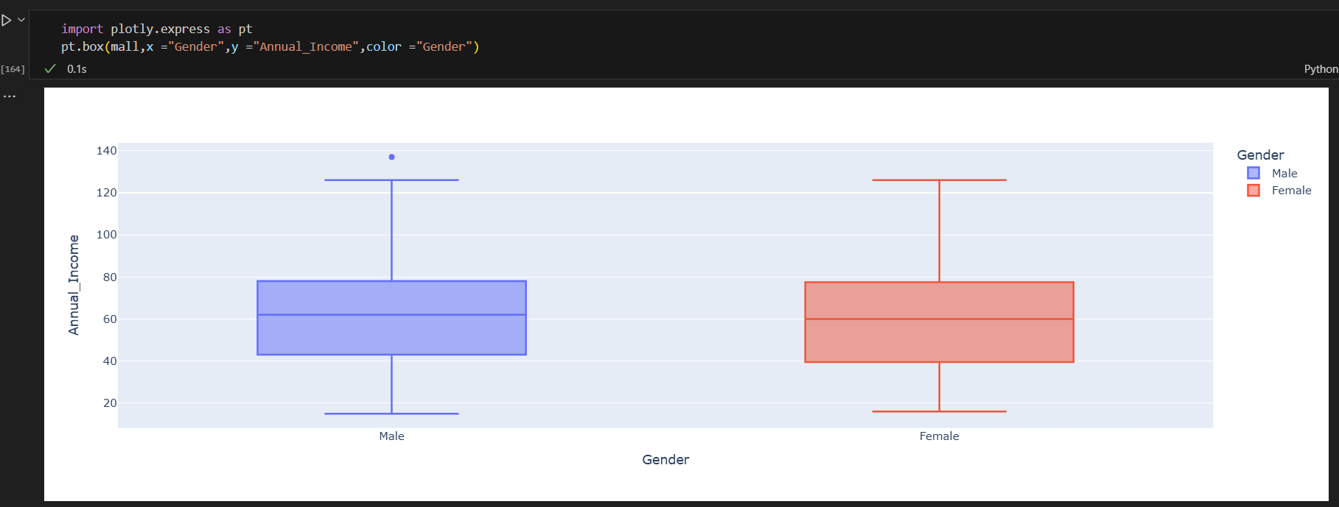
Figure 7
This plot shows how much money male and female customers make each year. Both groups have similar income ranges.
5.11 TO SHOW THE GENDER PROPORTION OF MALL CUSTOMER


Figure 8
This pie chart shows that most mall customers are female (about 55%) and the rest are male (about 45%).

5.12 TO VISUALIZE INCOME DISRIBUTION USING KDE PLOT
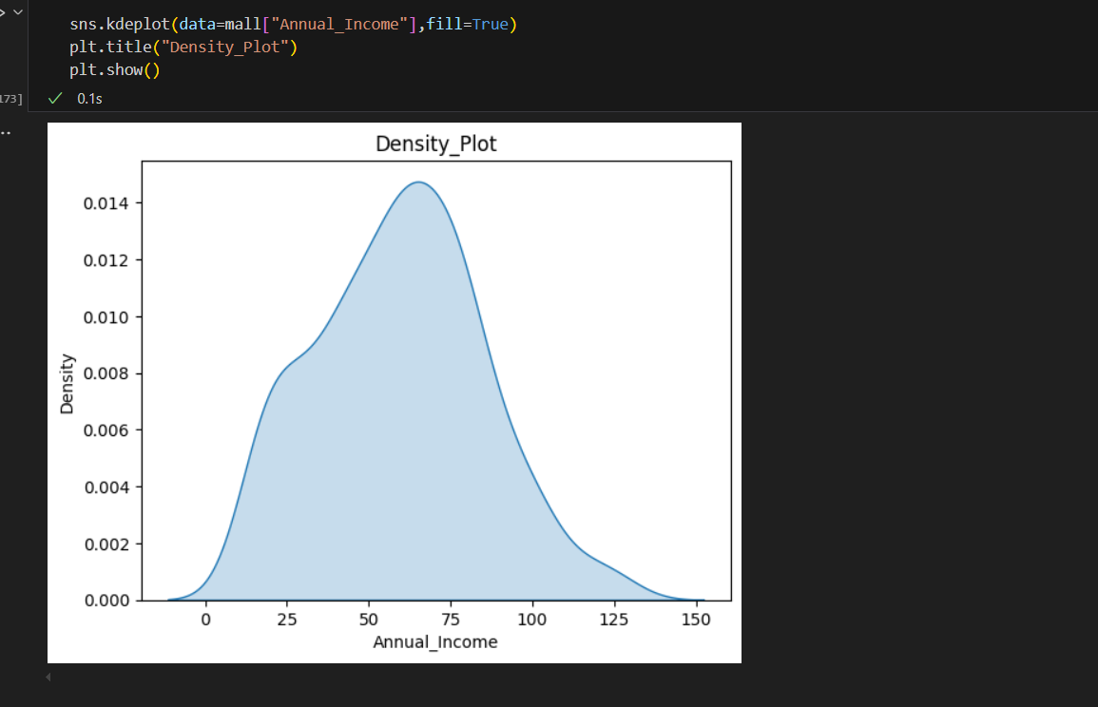
Figure 9
This smooth curve shows how many customers fall into each income group. Most people earn between ₹40,000 and ₹80,000.
5.13TO VISUALIZE SPENDING SCORE DISRIBUTION USING KDE
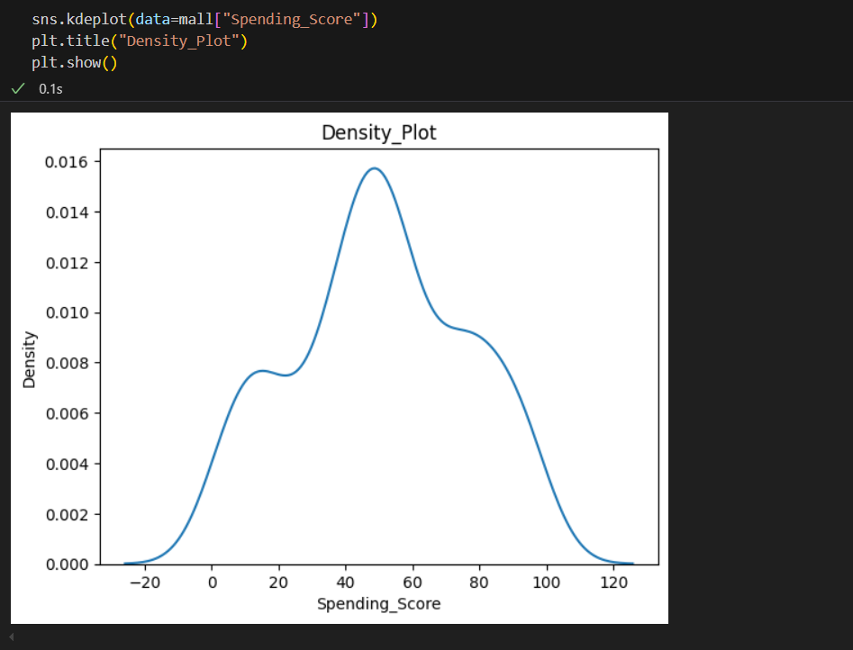
Figure 10
This graph shows that there are two groups of customers—some spend very little, while others spend a lot
5.14 TO VISUALIZE THE CORRELATION BETWEEN AGE, SPENDING SCORE,AND ANNUAL INCOME USING HEATMAP
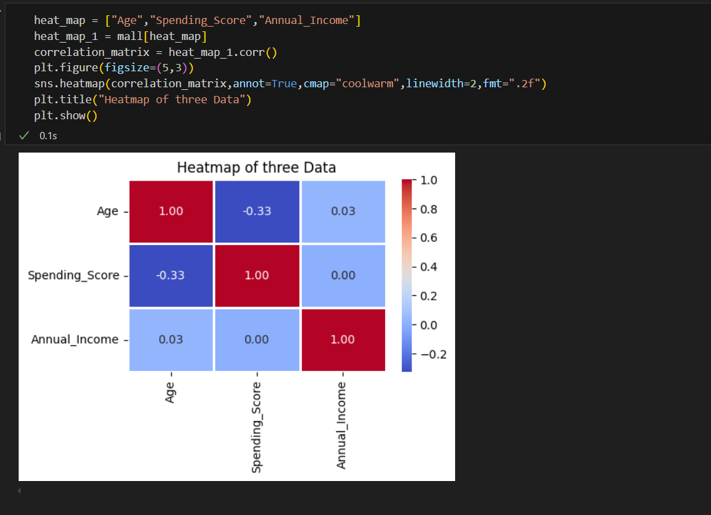
Figure 11
This heatmap shows the correlation between Age, Spending Score, and Annual Income.
A negative correlation is observed between Age and Spending Score, while Annual Income has very weak correlations with both.

CHAPTER VI
SUMMARY AND CONCLUSION
In this project, we utilized data analytics and the K-Means clustering technique to identify different segments of mall customers depending on their annual income and spending score. After initially analyzing the data and extracting patterns through univariate and bivariate analysis, we picked two main attributes to perform the clustering. The Elbow Method allowed us to choose an optimal number of clusters, which was five. Using K-Means, we were able to differentiate the customers into distinct groups that characterize the various shopping habits.
The findings identified obvious customer profiles, for example, high-income high-spending customers as well as low-income low-spending ones. Those clusters give insights to businesses, allowing them to target certain customers more effectively, improve customer engagement, and use their resources more efficiently. Even though the analysis was fruitful, the study included only two variables, and future expansion might bring more features for better segmentation. To sum up the project, it illustrates how machine learning can be a useful tool for implementing smart, data-driven business decisions.

CHAPTER VII
REFERENCES
- Kaggle Dataset – Mall Customer Segmentation
https://www.kaggle.com/datasets/vjchoudhary7/customer-segmentation-tutorial-in-python.
- Scikit-learn: Machine Learning in Python
https://scikit-learn.org/stable/modules/generated/sklearn.cluster.KMeans.html.
- Pandas Documentation
https://pandas.pydata.org/docs/.
- Matplotlib and Seaborn Libraries
https://matplotlib.org/
https://seaborn.pydata.org/
- Plotly Express Documentation
https://plotly.com/python/plotly-express/.
- Jupyter Notebook
https://jupyter.org/
- Python for Data Analysis by Wes McKinney (O’Reilly Media, 2nd Edition)
Towards Data Science Blog – Understanding K-Means Clustering
https://towardsdatascience.com/k-means-clustering-algorithm-applications-evaluation-methods-and-drawbacks-aa03e644b48a.
- Haider, Z., & Khan, A. (2020). Customer Segmentation and Profiling for Retailers: A Data-Driven Approach. Journal of Retail Analytics, 7(2), 45-60. https://doi.org/10.1016/j.jreta.2020.03.001
- Alharthi, A., & Alhazmi, S. (2021). Predictive Analytics in Mall Retail: A Case Study of Foot Traffic and Sales Prediction. International Journal of Retail and Distribution Management, 49(3), 277-289. https://doi.org/10.1108/IJRDM-06-2020-0262
- Sharma, R., & Gupta, A. (2018). A Data Science Approach to Retail Marketing: Predicting Consumer Preferences using Machine Learning. International Journal of Data Science and Analytics, 5(4), 202-212. https://doi.org/10.1007/s41060-018-0133-9
- Chen, X., & Yang, Y. (2019). Understanding Customer Behavior in Shopping Malls: A Data-Driven Approach. Journal of Consumer Research, 45(6), 1021-1035. https://doi.org/10.1086/701983

CHAPTER VIII
APPENDIX
#IMPORTING THE LIBRARIES FOR ANALYZING
import pandas as pd
import numpy as np
import matplotlib.pyplot as plt
import seaborn as sns
#LOADING AND VIEWING THE DATASET
mall = pd.read_csv("Mall_Customers - Mall_Customers.csv")
mall
#KNOWING ABOUT THE DATASET
- mall.head()
- mall.tail()
- mall.info()
- mall.describe()
- mall.isnull().sum()
# TO COUNT DISTRIBUTION OF CUSTOMER BASED ON AGE plt.figure(figsize=(5,4))
sns.countplot(x="Gender",data=mall,hue="Gender",palette=["Green","Orange"])
plt.title("Count Plot")
plt.show()
# TO COUNT COMPARISON OF AVERAGE SPENDING SCORE BY GENDER
plt.figure(figsize=(5,4))
sns.barplot(x="Gender",y="Spending_Score",data=mall,hue="Gender",errorbar=None)
plt.title("Count Plot")
plt.show()

#COUNT DISTRIBUTION OF CUSTOMER BASED ON SPENDING SCORE
sns.histplot(data=mall,x="Spending_Score")
plt.title("Histogram")
plt.show()
# COUNT DISTRIBUTION OF CUSTOMER BASED ON ANNUAL INCOME
sns.histplot(data=mall,x="Annual_Income")
plt.title("Histogram")
plt.show()
#TO ANALYSE THE AGE DISTRIBUTION AMONG GENDER USING BOX PLOT
sns.boxplot(x = "Gender",y = "Age", data = mall)
plt.title("Box Plot")
plt.show()
#TO ANALYSE THE DISTRIBUTION OF SPENDING SCORE ACROSS GENDERS USING BOX PLOT
import plotly.express as pt
pt.box(mall,x ="Gender",y ="Spending_Score",color ="Gender")
#TO ANALYSE THE DISTRIBUTION OF ANNUAL INCOME ACROSS GENDERS USING BOX PLOT
import plotly.express as pt
pt.box(mall,x ="Gender",y ="Annual_Income",color ="Gender")

# TO SHOW THE GENDER PROPORTION OF MALL CUSTOMER
import plotly.express as pt
fig = pt.pie(data_frame=mall,names="Gender")
fig.show()
#TO VISUALIZE INCOME DISRIBUTION USING KDE PLOT
sns.kdeplot(data=mall["Annual_Income"],fill=True)
plt.title("Density_Plot")
plt.show()
# TO VISUALIZE SPENDING SCORE DISRIBUTION USING KDE
sns.kdeplot(data=mall["Spending_Score"])
plt.title("Density_Plot")
plt.show()
#TO VISUALIZE THE CORRELATION BETWEEN AGE, SPENDING SCORE,AND ANNUAL INCOME USING HEATMAP
heat_map = ["Age","Spending_Score","Annual_Income"]
heat_map_1 = mall[heat_map]
correlation_matrix = heat_map_1.corr()
plt.figure(figsize=(5,3))
sns.heatmap(correlation_matrix,annot=True,cmap="coolwarm",linewidth=2,fmt=".2f")
plt.title("Heatmap of three Data") plt.show()

